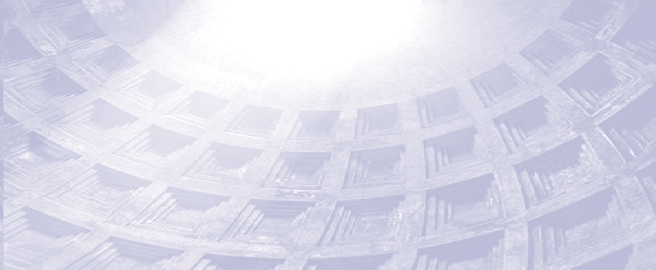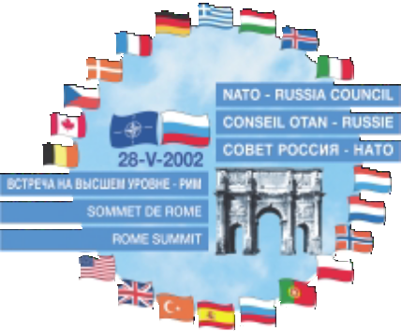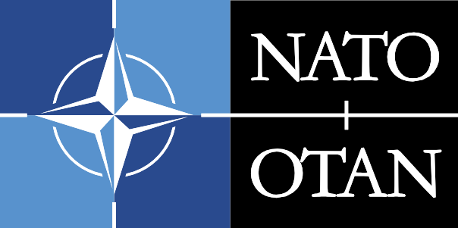
NATO - RUSSIA COUNCIL
ROME SUMMIT 2002

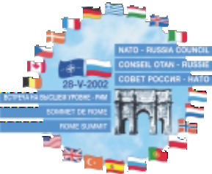
2

“At the start of the 21st century we live in a new, closely interrelated world, in which unprecedented new threats and challenges demand increasingly united responses. Consequently, we, the member states of the North Atlantic Treaty Organization and the Russian Federation are today opening a new page in our relations, aimed at enhanc- ing our ability to work together in areas of common interest and to stand together against common threats and risks to our security.”

Rome Summit Declaration, 28 May 2002



CONTENTS

- Introduction by NATO Secretary General
- NATO-Russia Relations: A New Quality
Declaration by Heads of State and Government of NATO Member States and the Russian Federation
- Statement by the NATO-Russia Council
- Decision Sheet of the Meeting of the NATO-Russia Council at the level of Heads of State and Government
- Opening remarks by NATO Secretary General
14 Addresses by Heads of State and Government

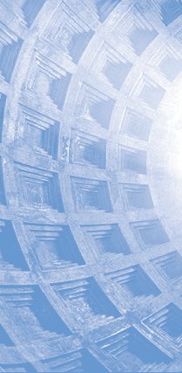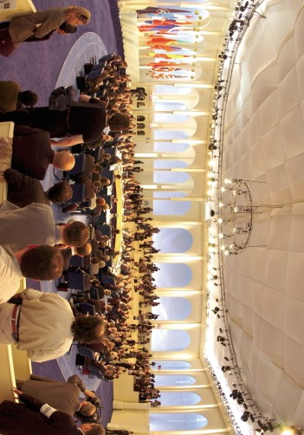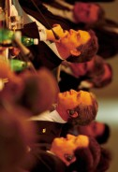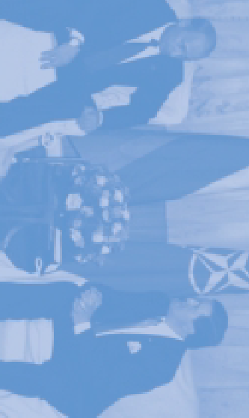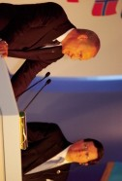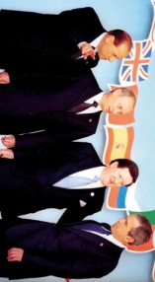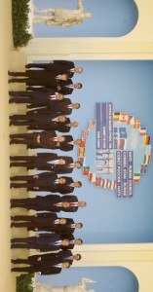
4

© Belga

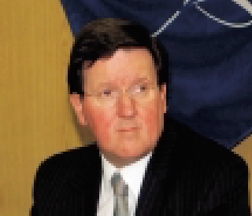
Introduction by NATO Secretary General

A new chapter in NATO-Russia relations was opened on 28 May 2002, when the heads of state and government of NATO member countries and of Russia gathered at Pratica di Mare Air Force Base, near Rome. A declaration on "NATO-Russia Relations: A New Quality" was signed, establishing a new NATO-Russia Council, which brings together the 19 Allies and Russia to identify and pursue opportunities for joint action "at 20".

The new Council provides a mechanism for consultation, consensus-building, cooperation, joint decision, and joint action. NATO's member states and Russia will work as equal partners on the basis of consensus on a wide range of Euro-Atlantic security issues. Continuous political dialogue will allow emerging problems to be identified early, common approaches to be determined or joint actions to be conducted, as required.

The Rome Declaration builds on the 1997 "Founding Act on Mutual Relations, Cooperation and Security", which remains the basic text governing relations between NATO and Russia. The ambitions expressed in the Founding Act were, however, never fully realised. In spite of the joint commitment to peacekeeping in the Balkans and the development of a substantial programme of practical security and defence-related cooperation, underlying inhibi- tions remained on both sides. The earlier Permanent Joint Council essentially remained a consultative forum with
NATO member countries coordinating all positions before meeting the Russians in the "19+1" format. 5

What was lacking from the earlier NATO-Russia dialogue was a true sense of shared purpose and urgency. The events of 11 September provided that impetus – a stark reminder of the need for comprehensive and coordinated action to respond to common threats.

While the struggle against terrorism is now at the heart of our cooperation, we have a much wider shared agenda. Many of today’s security challenges can only be met cooperatively. We are determined to go beyond consultation and to work constructively together on all issues where we have what Russian President Vladimir Putin calls "the logic of common interest".

The real difference between "19+1" and "20" is not a question of mathematics, but one of chemistry: the success of the NATO-Russia Council will depend on the political will of the participants. This has been evident at all levels in meetings held since the summit to transform the political message of Rome into practical cooperation and to grapple with the rules and procedures of the new structure, so that the prospects for a genuinely new quality in NATO-Russia relations appear bright.

This publication was prepared to mark the significance of the Rome Summit. It is a compilation of the speeches delivered and the text of the Rome Declaration itself. I hope you will find it interesting and memorable reading.

Lord Robertson of Port Ellen


NATO-Russia Relations:A New Quality

Declaration by Heads of State and Government of NATO Member
States and the Russian Federation

At the start of the 21st century we live in a new, closely interrelated world, in which unprecedented new threats and challenges demand increasingly united responses. Consequently, we, the member states of the North Atlantic Treaty Organization and the Russian Federation are today opening a new page in our rela- tions, aimed at enhancing our ability to work together in areas of common interest and to stand togeth- er against common threats and risks to our security. As participants of the Founding Act on Mutual Relations, Cooperation and Security, we reaffirm the goals, principles and commitments set forth there- in, in particular our determination to build together a lasting and inclusive peace in the Euro-Atlantic area on the principles of democracy and cooperative security and the principle that the security of all states in the Euro-Atlantic community is indivisible. We are convinced that a qualitatively new rela- tionship between NATO and the Russian Federation will constitute an essential contribution in achiev- ing this goal. In this context, we will observe in good faith our obligations under international law,
6 including the UN Charter, provisions and principles contained in the Helsinki Final Act and the OSCE Charter for European Security.

Building on the Founding Act and taking into account the initiative taken by our Foreign Ministers, as reflected in their statement of 7 December 2001, to bring together NATO member states and Russia to identify and pursue opportunities for joint action at twenty, we hereby establish the NATO-Russia Council. In the framework of the NATO-Russia Council, NATO member states and Russia will work as equal partners in areas of common interest. The NATO-Russia Council will provide a mechanism for consultation, consensus-building, cooperation, joint decision, and joint action for the member states of NATO and Russia on a wide spectrum of security issues in the Euro-Atlantic region.

The NATO-Russia Council will serve as the principal structure and venue for advancing the relationship between NATO and Russia. It will operate on the principle of consensus. It will work on the basis of a continuous political dialogue on security issues among its members with a view to early identification of emerging problems, determination of optimal common approaches and the conduct of joint actions, as appropriate. The members of the NATO-Russia Council, acting in their national capacities and in a man- ner consistent with their respective collective commitments and obligations, will take joint decisions and will bear equal responsibility, individually and jointly, for their implementation. Each member may raise in the NATO-Russia Council issues related to the implementation of joint decisions.

The NATO-Russia Council will be chaired by the Secretary General of NATO. It will meet at the level of Foreign Ministers and at the level of Defence Ministers twice annually, and at the level of Heads of State and Government as appropriate. Meetings of the Council at Ambassadorial level will be held at least once a month, with the possibility of more frequent meetings as needed, including extraordinary meet- ings, which will take place at the request of any Member or the NATO Secretary General.

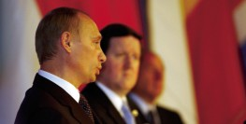

To support and prepare the meetings of the Council a Preparatory Committee is established, at the level of the NATO Political Committee, with Russian representation at the appropriate level. The Preparatory Committee will meet twice monthly, or more often if necessary. The NATO-Russia Council may also establish committees or working groups for individual subjects or areas of cooperation on an ad hoc or permanent basis, as appropriate. Such committees and working groups will draw upon the resources of existing NATO committees.

Under the auspices of the Council, military representatives and Chiefs of Staff will also meet. Meetings of Chiefs of Staff will take place no less than twice a year, meetings at military representatives level at least once a month, with the possibility of more frequent meetings as needed. Meetings of military experts may be convened as appropriate.

The NATO-Russia Council, replacing the NATO-Russia Permanent Joint Council, will focus on all areas
of mutual interest identified in Section III of the Founding Act, including the provision to add other 7
areas by mutual agreement. The work programmes for 2002 agreed in December 2001 for the PJC and its subordinate bodies will continue to be implemented under the auspices and rules of the NATO-Russia Council. NATO member states and Russia will continue to intensify their cooperation in areas includ- ing the struggle against terrorism, crisis management, non-proliferation, arms control and confidence- building measures, theatre missile defence, search and rescue at sea, military-to-military cooperation, and civil emergencies. This cooperation may complement cooperation in other fora. As initial steps in this regard, we have today agreed to pursue the following cooperative efforts:

- Struggle Against Terrorism: strengthen cooperation through a multi-faceted approach, includ- ing joint assessments of the terrorist threat to the Euro-Atlantic area, focused on specific threats, for example, to Russian and NATO forces, to civilian aircraft, or to critical infrastructure; an ini- tial step will be a joint assessment of the terrorist threat to NATO, Russia and Partner peacekeep- ing forces in the Balkans.

- Crisis Management: strengthen cooperation, including through: regular exchanges of views and information on peacekeeping operations, including continuing cooperation and consultations on the situation in the Balkans; promoting interoperability between national peacekeeping contin- gents, including through joint or coordinated training initiatives; and further development of a generic concept for joint NATO-Russia peacekeeping operations.

- Non-Proliferation: broaden and strengthen cooperation against the proliferation of weapons of mass destruction (WMD) and the means of their delivery, and contribute to strengthening exist- ing non-proliferation arrangements through: a structured exchange of views, leading to a joint

assessment of global trends in proliferation of nuclear, biological and chemical agents; and exchange of experience with the goal of exploring opportunities for intensified practical coopera- tion on protection from nuclear, biological and chemical agents.

- Arms Control and Confidence-Building Measures: recalling the contributions of arms control and confidence- and security-building measures (CSBMs) to stability in the Euro-Atlantic area and reaffirming adherence to the Treaty on Conventional Armed Forces in Europe (CFE) as a corner- stone of European security, work cooperatively toward ratification by all the States Parties and entry into force of the Agreement on Adaptation of the CFE Treaty, which would permit accession by non-CFE states; continue consultations on the CFE and Open Skies Treaties; and continue the NATO-Russia nuclear experts consultations.

- Theatre Missile Defence: enhance consultations on theatre missile defence (TMD), in particular on TMD concepts, terminology, systems and system capabilities, to analyse and evaluate possible levels of interoperability among respective TMD systems, and explore opportunities for intensified practical cooperation, including joint training and exercises.

- Search and Rescue at Sea: monitor the implementation of the NATO-Russia Framework Document on Submarine Crew Rescue, and continue to promote cooperation, transparency and confidence between NATO and Russia in the area of search and rescue at sea.

8 * Military-to-Military Cooperation and Defence Reform: pursue enhanced military-to-military cooperation and interoperability through enhanced joint training and exercises and the conduct of joint demonstrations and tests; explore the possibility of establishing an integrated NATO-Russia military training centre for missions to address the challenges of the 21st century; enhance coop- eration on defence reform and its economic aspects, including conversion.

- Civil Emergencies: pursue enhanced mechanisms for future NATO-Russia cooperation in responding to civil emergencies. Initial steps will include the exchange of information on recent disasters and the exchange of WMD consequence management information.

- New Threats and Challenges: In addition to the areas enumerated above, explore possibilities for confronting new challenges and threats to the Euro-Atlantic area in the framework of the activi- ties of the NATO Committee on Challenges to Modern Society (CCMS); initiate cooperation in the field of civil and military airspace controls; and pursue enhanced scientific cooperation.

The members of the NATO-Russia Council will work with a view to identifying further areas of cooperation.

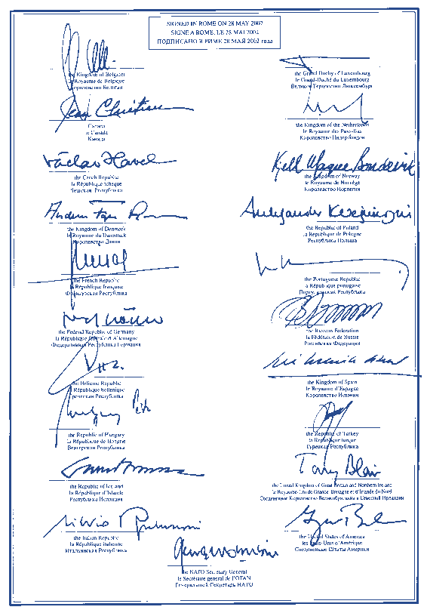

9

Statement

NATO-Russia Council

Today, we have launched a new era in NATO-Russia cooperation.

We, the Heads of State and Government of the member states of the North Atlantic Treaty Organisation and the Russian Federation, have today signed a Declaration, "NATO-Russia Relations: A New Quality", establishing a new body, the NATO-Russia Council, which we are committed to making an effective forum for consensus-building, consultations, joint decisions and joint actions.

We enter into this new level of cooperation with a great sense of responsibility and equally great resolve to forge a safer and more prosperous future for all our nations.

In the NATO-Russia Council, NATO member states and Russia will work as equal partners in areas of common interest. Building on the Founding Act and its wide range of cooperation, the NATO-Russia Council will intensify efforts in the struggle against terrorism, crisis management, non-proliferation of weapons of mass destruction, arms control and confidence-building measures, theatre missile defence, search and rescue at sea, military-to-military cooperation and defence reform, and civil emergencies, as
10 well as in other areas. We are united in our resolve to overcome the threats and challenges of our time.

We have agreed to an ambitious work programme that will guide our cooperation in the coming months. We will pursue specific projects in areas important to Euro-Atlantic security. We are determined to pro- duce concrete results that will benefit the peace and security of all our people, and will contribute to steadily increasing cooperation between us.

We will take stock of our progress at future meetings.

Decision Sheet
of the Meeting of the NATO-Russia Council at the level of Heads of State and Government

- Adoption of the Rome Declaration

- following an introductory statement by the Chairman, the Heads of State and Government of NATO Member States and Russia, adopted the Declaration on
"NATO-Russia Relations: A New Quality," and decided that:

  - the present Declaration takes effect upon the date of its signature;

  - the members of the NATO-Russia Council would take the proper steps to ensure its implementation in accordance with their procedures;

  - the present Declaration was established in two originals in the French, English and Russian Language;
  - the Secretary General of NATO in his capacity as Chairman of the NATO-Russia 11
Council would provide the Secretary General of the United Nations and the
Secretary General of the OSCE with the text of this Declaration with the request to circulate it to all members of their Organisations.

Opening remarks by Lord Robertson
NATO Secretary General

Good morning and welcome

Bonjour et bienvenue
,Dоброе утро и добро пожаловать!

I am delighted to convene this meeting today of the Heads of State and Government of the NATO countries and Russia. We meet here on the outskirts of Rome thanks to the generous invitation of Prime Minister Silvio Berlusconi and the Italian people, to whom we are most grateful.

Over the centuries Rome has inspired so much in the world’s culture and democracy. It is therefore fitting and appropriate that the “eternal city” hosts this most important event. The opening of this meeting begins a completely new chapter in Euro-Atlantic relations. Even today’s table plan is a remarkable reversal of contemporary history.

The leaders of twenty of the world’s most powerful nations assembled, not to carve up the world, but to unite it. Twenty nations stretching from Vancouver to Vladivostok around one table address- ing issues where common interests call for common solutions. We, meeting here today, are a living
12 contradiction of the forces that divided and weakened a continent for two generations. For every-
one who despaired during the frozen stretches of the Cold War, this gathering represents a hope of a better, saner future.

As a result, there will be high expectations of all. Expectations that this will not be just another glitzy protocol event, but a real breakthrough. Expectations that the new NATO-Russia Council will not just talk but will act, not just analyse but prescribe, not just deliberate but take decisive action. We have a profound obligation to ensure that these expectations are not disappointed. And if we need a reminder of why, then there is a simple answer. There is a common enemy out there. The man and woman in the street, be it Petrovka Street or 66th Street, knows it, feels it and they expect us to address it. The 11 September 2001 brought death to thousands of people in one act of terrible, criminal violence. But it also brought a message to the leaders of the democratic world. Find solu- tions and find them together.

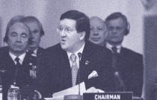

Five years ago NATO and Russia signed the Founding Act and created the Permanent Joint Council. It was enough then – it is simply not enough now. That is why we are here as a new NATO-Russia Council. It is why we have created a new mechanism to facilitate the search for com- mon ground and common understanding to meet common challenges and stop that common enemy. We need a new qualitatively better relationship – and we need a new mindset to make it happen.

With that thought in mind, may I now ask you to adopt the Declaration submitted to you by your Foreign Ministers after their meeting in Reykjavik, entitled “NATO-Russia Relations: A New Quality”, and to approve the draft decision sheet in front of you.

The Rome Declaration and the decision sheet are hereby adopted.
Thank you. The Declaration will be signed at the end of the meeting and published this afternoon. 13
In making this decision you have formally brought into existence the NATO-Russia Council - where all members around this table will work together as equal partners. I am very conscious of the responsibility I take on as the first Chairman of this NATO-Russia Council. I promise to you, and to those who watch us outside, my full commitment to make this new Council work, and work well. But the success or failure of this Council will not be determined by me, but by you - the leaders of the NATO countries and of Russia.
So, I ask you tell your people to work together in the logic of common interests and if they do, and only if they do, the NATO-Russia Council will work and fulfil the reasonable expectations of those who trust us with their security and safety.

Address by Silvio Berlusconi
Prime Minister of Italy

Thank you George, thank you all for being here today. It is a great honour for me to welcome you to my Country.

I am particularly pleased that this meeting should be held before it was thought to be possible, and also pleased that it could be held today, a few months ahead of the Prague meeting.

I believe everyone has contributed to the success of this agreement. Secretary General Lord Robertson, for his part, has been following developments in the situation with constant attention. However I think we should all be particularly grateful to President Bush and President Putin, leaders whom I have both admired on this occasion.

President Bush won my admiration for his prudence, his wisdom and his far-sightedness; President Putin for the determination, the tenacity he has shown in his desire to achieve these results.

I would also like to thank Tony Blair and everyone else: we have all been working in the conviction that the moment had come to write a new chapter in history.

14
It was decided to hold this Summit in Rome, a city indeed steeped in history, where many historic treaties have been signed.

We were requested to guarantee maximum security. This is the reason why, instead of holding this event in the location I originally had in mind in Rome, we decided to gather here, inside an air base, to ensure we would indeed enjoy maximum security.

In twenty days, as you can see, we managed to erect a venue which by tomorrow will have van- ished. This is a real pity. But I believe this setting is worthy of the momentous event we are celebrating.

We know that history is determined by the choices made by human beings, and we, in this case, are making an important choice.

Sometimes, though, history can also be written by chance. In fact, I should tell you that the area we are in today, by chance, happens to be the area where Aeneas, having fled Troy, landed togeth- er with his father Anchises and his son Iulus. He had received a prophecy: “You will leave the East, but in the West you will found a city larger and more beautiful than Troy.”

Aeneas came here, fell in love with Lavinia, daughter of the local king Latinus, and founded the city of Lavinium in her honour. With the king’s daughter, he gave birth to a dynasty. Romulus and Remus were born, and founded Rome, a city larger and more beautiful than Troy, thus fulfilling the prophecy.

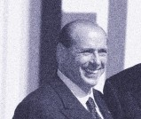

So two cultures and two peoples merged: the East, with Aeneas, and the West, with Latinus. This is precisely what is taking place today, the East of Europe joining with the West.
I sincerely believe that this bond will be a decisive one for history and for world security.

I would like to thank -– and I believe we should all do so on behalf of our fellow citizens – George and Vladimir, who did not come here empty-handed.

They came here to present us with the agreement they signed a few days ago on the reduction of nuclear warheads.

This agreement is of great significance: the elimination of two thirds of warheads is a truly impor- tant decision. However I would like to recall the old adage, “well begun is half done”. There are still warheads to be destroyed, and I personally think that we should only retain those that are absolutely indispensable to our security.

15
Our sincere thanks, from me and from all Italians. I believe they are all grateful for what you achieved after so many years.

A new Council. We are all aware that our main goal is to defend and safeguard the security of our peoples. We must confront the new worldwide emergency, the new folly of international terrorism, we must counter the increase in the production of weapons of mass destruction; we must combat criminal organisations, drug and human trafficking; we must address regional crises, prevent and contain them through peace-enforcing and peace-keeping operations, we must intervene in the so- called civil emergencies.

These are the aims of this treaty.

But when yesterday my children asked me what our ultimate goal was, I thought that the real objec- tive we should pursue was to make this century a century of democracy and peace.

Only if democracy expands to the countries which today are deprived of it, and only if we succeed in promoting the freedom we enjoy in our Countries, will we be able to claim that we have put up a real barrier against the outbreak of new wars.

This is therefore the objective we should be pursuing: expanding democracy and freedom, the defining features of our Countries. If we were to lock ourselves up inside our Western fortress, our freedom would eventually decline and perish.

We must bring democracy and freedom to all peoples.

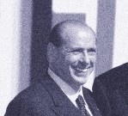

What are the messages which should emerge from this Summit. Only two and I hope they will meet your approval.

In the first message, I would like to tell women and men in all our Countries that what we are achiev- ing here today will guarantee a more peaceful and secure future for them. We are stronger than before, we have done away with the differences between us, done away with the nightmare of two nuclear arsenals facing one another.

The Russian Federation is with us, and the West is with the Russian Federation. With this agree- ment, we are truly securing a more peaceful future for our children.

That is the first message.

The second message is for the terrorists and those who support them.

They too should know that we are stronger now and that they will never be able to defeat us. They
16 should therefore give up their insane schemes, because they do not stand a chance of ever pre-
vailing.

Thank you again, George, Vladimir, Tony and all of you.

I feel truly honoured. Today’s meeting will remain one of the finest memories of my life.

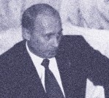Address by Vladimir Putin
President of the Russian Federation

First of all, my heartfelt thanks to our Italian friends and personally to Mr Silvio Berlusconi, President of the Italian Council of Ministers, for their hospitality and the excellent organisation of the summit. I can imagine how difficult it was to do all this in such a short time.

It would be difficult to overestimate the significance of the Summit. Even quite recently, this kind of meeting between the leaders of Russia and the NATO member nations, given the format and qual- ity it has today, would have been simply unthinkable. It has now become a reality – one which is possible thanks to intensive joint work and the willingness to engage in lively and open dialogue.

Twenty influential world States have realised that they have common vital security interests in a fast-changing international situation. They have realised sufficiently both the need for increased mutual understanding and the global danger of the new threats. First and foremost – the threat of international terrorism.

On 11 September last year, terror claimed thousands of lives in New York. And quite recently, on 9 May, the day of the Great Victory over Fascism, terrorists spared neither women, old people nor
children in the Russian town of Kaspiisk. They violated the memory of those who gave the world 17
freedom and hope.

We should remember that ,more than a half a century ago, humanity paid with tens of millions of lives for the criminal short-sightedness and hesitation of politicians in joining forces against the com- mon enemy. We are now facing a task which is comparable in scale by historical standards. Yes, the current threat is in a new guise and has a different ethos, but it is no less dangerous for the fate of humanity.

And this is why all the institutions and forms of international cooperation are now being tested for both their relevance and their adequacy to meet the new challenges. We know that this test will not be easy. We will need time, and this is something the Secretary General recently wrote to me about. I completely agree about this. We will need patience and firm political will. But this is the only way for us to form a truly effective architecture, which can reliably protect both our common interests and indivisible peace and security.

As realists, we recall that the history of relations between Russia and the North Atlantic Alliance has not been easy. We have come a long way – from opposition to dialogue, from confrontation to coop- eration. And we fully understand that the signing of the Rome Declaration is only the beginning of building fundamentally different relations. And indeed, I can confirm what our distinguished host, the Italian Prime Minister, said, President Bush and I talked a great deal about this in Moscow.

But I have to say that the decision to move to a new quality of Russia-NATO relations has been cor- rectly perceived by millions of Russians. I think that the people of Western Europe, the USA and Canada also see this step as evidence of our common willingness to bear the burden of responsi-

bility for maintaining peace and stability on the planet. Our starting point here is the clear under- standing that neither nuclear missile potential nor Cold War commitments can any longer be the panacea for modern threats – indeed they are not.

We are signing a Declaration which clearly defines the principles of cooperation, establishes the mechanism in the form of the new NATO-Russia Council, and already sets out the initial areas in which our joint efforts will be applied. And we therefore firmly trust that the Rome document is not a statement of intentions, but a sound basis for constructive joint work.

Russia is primarily interested in it as a working instrument. It is of fundamental importance that cooperation at twenty should be based on a firm foundation of international law – the UN Charter, the Helsinki Final Act and the OSCE Charter on European Security. With this we will build the new Council into the network of mutually complementary efforts by worldwide and regional organisations working in the area of security.

For Russia, with its geopolitical position, the enhancement of cooperation with NATO as equal part-
18 ners is one of the real embodiments of the multiple approach, to which there is no alternative and which we intend to pursue resolutely. We do not think of ourselves as outside Europe, but it is also unthinkable for us that the role of approved cooperation mechanisms in Asia and in the Commonwealth of Independent States should be underestimated. Only by harmoniously combin- ing our actions in all these areas will we open up wide-ranging possibilities for building a single security region – from Vancouver to Vladivostok. I think that the participants in today's meeting share this opinion.

Today, we are holding our very first meeting at twenty. We hope that our relations with NATO will continue to expand and that the quality of our relations will improve. And our difficult work, which is important to us all, will be built not only on mutual respect, but also on the committed search for new common ground. Only thus can the logic of common interests be transformed into the logic of joint action. And I believe that this is one of the main tasks of the NATO-Russia Council.

In conclusion, I should like to say once again: the new reality of our relations directly reflects the new level of mutual understanding. I think that the joint efforts we have made in the cause of peace must continue. We have no alternative.

I would like to give my heartfelt thanks to all of you who are gathered here today at this roundtable of harmony and mutual understanding. We know that without the goodwill and understanding of everyone of the importance of what is happening, this meeting would not have taken place and achieved the results it has today. I want to assure you that Russia understands the level of its responsibility.

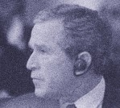Address by George W. Bush President of the
United States of America

Secretary General, thank you for your leadership. Prime Minister, thank you for your grand hospi- tality. You have been a great host. And I want to welcome our friend, President Vladimir Putin, to this table and all my NATO colleagues.

Today marks an historic achievement for a great alliance and a great European nation. Two former foes are now joined as partners, overcoming fifty years of division and a decade of uncertainty. And this partnership takes us closer to an even larger goal: a Europe that is whole, free and at peace for the first time in history.

NATO was born over a half a century ago as an alliance committed to defending democracy and advancing freedom. Today, we renew our commitment to these important goals. And as we reach out to a new Russia that is building freedom in its own land and is already joining us in defending freedom against a common enemy, we do so in the spirit of peace and friendship.

The attacks of 11 September made clear that the new dangers of our age threaten all nations, including Russia. The months since have made clear that by working together against these threats,
we multiply our effectiveness. 19

The NATO-Russia Council gives us the opportunity to move forward together on common chal- lenges and to begin building ties that can be expanded far into the future. We will start with areas where our ability to help one another as equal partners is unmistakable, areas such as countering terrorism, preventing the spread of weapons of mass destruction, emergency planning, and search and rescue operations at sea.

We will improve our coordination in places where we are already working together, such as the Balkans. NATO, Russia and our other partners can take great pride in the greater peace and sta- bility we have brought to that region.

We will also look ahead to other areas, where we can expand our cooperation, such as missile defence and airspace control that can strengthen the security of all of Europe. Nothing we do will subtract from NATO’s core mission. We will be practical, moving forward step by step. And as our trust and track record of success grows, so will the breadth and depth of our work together.

The NATO-Russia Council offers Russia a path toward forming an alliance with the Alliance. It offers all our nations a way to strengthen our common security, and it offers the world a prospect of a more hopeful century.

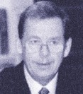Address by Václav Havel
President of the Czech Republic

Our meeting today marks the beginning of a qualitatively new era of cooperation between NATO and the Russian Federation. May this cooperation be not merely a formal relationship or a matter of politeness, but a genuine, practical collaboration focusing precisely on those specific tasks for which it is useful to seek solutions jointly and mutually. I believe that if the present global civilisation is to succeed in averting the various major threats looming over it as a result of its amazing, but somewhat one-sided development, all the major entities of today’s world must work closely togeth- er as equal partners.

Therefore, just as NATO, or the part of the world encompassed within NATO, is now deepening its relations with the Russian Federation, the Alliance should soon begin to deepen its relations with the other large entities of the contemporary world as well. For example, it would be quite unfortu- nate if the partnership we have established today created the impression that the more affluent northern hemisphere is uniting at the expense of the southern hemisphere. One way or another, the entire planet should move toward unity. All the world’s inhabitants desire to live in peace, freedom and prosperity. Differences between cultures or spheres of civilisation should be an impulse to pro- mote better knowledge of one another, more profound understanding and greater mutual respect,
20 and not a reason for enmity or even a pretext for confrontation.

The next regular, long-planned NATO meeting, being prepared by the Czech Republic with great care, will be held in Prague this coming November. My country’s capital city will be visited, I hope, not only by all of you, but also by many other participants representing our numerous partner states. It is my firm belief that this forthcoming summit will not only confirm the new role of the Alliance in the new millennium. It will also bear witness to the practical effectiveness of our newly initiated rela- tionship with Russia, and to NATO’s commitment to gradually building and intensifying its relations with all the other parts of the present-day world.

NATO was originally founded as a response to Stalin’s subjugation of my country. May its summit meeting in Prague manifest to the whole world, once and for all, that the time of subjugation is over and an era of worldwide cooperation has begun.

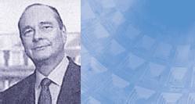Address by Jacques Chirac
President of the French Republic

I should like to begin by expressing my great appreciation to the President of the Italian Council of Ministers for the hospitality he has shown us and for the excellent organisation of the summit. I should also like to congratulate him on the exceptional quality of the summit – and on the speed of the arrangements, which, coming from the Italians, does not surprise me. We are happy to be his guests today.

Ever since the collapse of the Soviet regime, France has hoped that Russia, a great nation in the history of humanity, would regain its place as part of the European continent. The most spectacu- lar symbol of this rapprochement is the new relationship which has become possible between Russia and NATO. A bastion of freedom and democracy for fifty years, the Atlantic Alliance had a duty to evolve; it had a duty to open its doors to the new wind of freedom and democracy blowing in Europe. It was in this spirit that France proposed that Russia be involved in all our work. This ini- tiative led to the signature of the Founding Act in Paris in May 1997.

Since then, the world has undergone profound changes and Russia has pursued its modernisation efforts effectively and intelligently, spurred on and guided by President Putin. And I wish to tell
President Putin that France is glad that he is here today so that we can tackle our continent’s major 21
security issues together and in a spirit of full cooperation. For the moment has come to turn a new page and welcome Russia as a full partner of a Council on which the twenty members will sit on a strictly egalitarian footing, just as we are sitting around this table today.

I hope that the mechanisms we establish today will be implemented resolutely and, above all, con- fidently, for, as everyone knows, it is not enough for a text to be adopted – the most important thing is that it should be translated into reality. We must establish work patterns. These changes must be taken to heart in both diplomatic and military circles.

In order to meet the expectations created by the declaration we have approved today, it is essen- tial that the joint decisions or actions that we can now take together relate to the key areas of NATO’s competence, such as crisis management in Europe, particularly the Balkans, disarmament or non-proliferation.

With the transformation of the relationship with NATO there must, of course, also be closer links with the European Union, whose global competencies are such that partnership can be developed in all areas. Tomorrow’s EU-Russia Summit will be a natural contribution in this spirit.

Let us welcome today this new step towards a more unified and harmonious continent in which, thanks inter alia to the agreement signed by President Bush and President Putin in Moscow two days ago, Russia can now fulfil the role of the great nation it has never ceased to be throughout the vicissitudes of history. Thus we can together take up the new security challenges facing the Euro- Atlantic region.

Address by
Aleksander Kwasniewski
President of the Republic of Poland

When thirteen years ago I participated in the Warsaw Round-Table Talks, no-one among us expect- ed that this road would lead us today to Rome. Neither then nor at the time of the fall of the Berlin Wall did even the boldest visionaries foresee the meeting that is taking place now. Today there is no Communism in Europe, no Warsaw Pact, no balance of fear. We, Poles, have great satisfaction that the construction of a better, united and secure Europe of free people began in Poland and has achieved the present phase here, in Rome.

NATO and Russia, already back in 1997, established cooperation and structures to facilitate regu- lar consultations. Much had to happen afterward, more tests of international solidarity had to be passed in the face of new threats. The 11 September 2001 made the world redefine its security pri- orities and effective defence methods. Russia has strongly defined herself. As a participant in the anti-terrorist coalition she helped to successfully complete the first phase of the Afghan war, giving the world hope and conviction that we are all determined and united in this difficult struggle.

Today, at this table, are Allied Heads of State and Government and the President of the Russian Federation, Vladimir Putin. Under your leadership, Mr President, Russia has chosen this path and
22 has got closer to the Alliance. The new NATO-Russia Council is yet another important step in mutu- al relations. As President of the Republic of Poland, a NATO member since 1999 and Russia’s neighbour for centuries, I am satisfied that Poland has made its contribution to the building of good relations and that doubts expressed in the past about these relations after Poland’s accession to the Alliance have not proved right.

It is Poland’s desire that NATO and Russia, by concrete actions and joint decisions, become more and more responsible for peace and stability in the world. The Council will be a success story as long as its existence is filled with substance and mutual trust. However, we need to convince Russian citizens that NATO is not an old enemy or rival, but a trustworthy and necessary partner. We are looking forward to the Russian authorities taking up this challenge. The NATO-Russia rap- prochement must not be a sole decision of élites, it must take place in the minds of people.

We are facing other important decisions. Following a wise and far-sighted policy, the North Atlantic Alliance will make decisions on NATO enlargement at November’s summit meeting in Prague. Strengthening the Alliance with new members is part of its evolution and role as security guarantor. Especially now that candidate countries are already not only consumers of security but are also security contributors in their own right, as seen in the Balkans or in Afghanistan. This is why it is in NATO’s strong political and strategic interest to invite new states aspiring for membership. Defining new substance and format of cooperation with Ukraine will serve the same purpose.

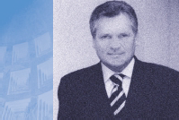

This process will be favourable for the stability in the continent, mitigate potential tensions between individual countries, and be conducive to blurring old divisions. It reinforces the sense of freedom and democratic transparency. I appreciate that Russia is also aware of the benefits and new oppor- tunities resulting from NATO enlargement and cooperation with Ukraine.

Poland is certain that the Alliance will preserve its functions, structure and effectiveness, remain the guarantor of the US military presence in Europe and the guarantee of Europe’s security. And secu- rity is the guarantee of Europe’s unity.

Today, from Italy, we are sending an optimistic signal to the world. Joined by responsibility and determination to cooperate, NATO and Russia:
- at one table
- on an equal footing
- in the interest of Europe and the world.

23

Address by
Ahmet Necdet Sezer
President of the Republic of Turkey

It is my pleasure to attend this historic meeting. My thanks to our Host, His Excellency Prime Minister Berlusconi and the Italian Government, for the warm hospitality and for the facilities pro- vided to organise this meeting that records the rapprochement between NATO and Russia, which will contribute significantly to the Euro-Atlantic security, as well as to global security.

I would also like to express our pleasure in seeing Mr Putin, President of the Russian Federation, among us as an equal member of this Council. I welcome him wholeheartedly. We support the steps taken by President Putin in the pursuit of Russia’s closer integration with Euro-Atlantic struc- tures and hope that they will continue.

The Russian Federation is a key player in the security, stability and prosperity of the Euro-Atlantic region. Moreover, the stability and prosperity of Russia as well as its commitment to our shared val- ues, embodied in NATO, are important. Our generation has intensively experienced the tensions and fears of the Cold War. The fall of the Berlin Wall and subsequent developments removed these fears. Today, we are embarking on a new journey on the basis of mutual trust, breaking down the walls of suspicion in our memories.

24
On 27 May 1997, with the signature of the NATO-Russia Founding Act, NATO and the Russian Federation confirmed that they were no longer adversaries. Five years later, with today’s new Declaration, the equal partnership between NATO and Russia is being registered irreversibly in the annals of history at the highest level.

The new security environment emerging in the Euro-Atlantic region requires more intense cooper- ation with the Russian Federation. NATO’s external adaptation, the European Union’s enlargement and emergence as a new security player, risks and threats in the wake of 11 September 2001, ter- rorism in the Eurasia region, extremist movements, the danger of the proliferation and use of weapons of mass destruction – all these compel us to act together to defend the future of our peo- ples as well as of our common civilisation.

Among the priority goals of Turkish foreign policy is the strengthening of our bilateral cooperation with our friend and neighbour, Russia, and elevating it to an advanced level of partnership for our mutual benefit. We know that Russia shares the same determination.

Turkey considers Russia, with which it has had relations for centuries and shared the same geog- raphy, not as a rival but a partner of cooperation. Constructive and creative cooperation in the area covering the Black Sea, the Balkans, the Caucasus and Central Asia will contribute to the security, stability and economic prosperity of not only our two countries, but also the whole Euro-Atlantic region. With this understanding, an Action Plan for cooperation in Eurasia was signed between Turkey and Russia.

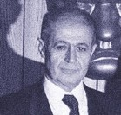

Today’s summit meeting coincides with the tenth anniversary of the bilateral Agreement on the Principles of the Relations between Turkey and Russia, signed on 25 May 1992, in the aftermath of the end of the Cold War. This adds particular value, on our part, to today’s event.

We believe that the work of the new Council in the selected areas identified for consultation, joint decision and joint action will contribute significantly to addressing common risks and threats. In this context, I would like to underline the importance Turkey attaches to the fight against terrorism, which is also among the priority objectives of the Council. Having lost thousands of its citizens to terrorism, the Turkish nation has learnt bitterly the scope of this threat. Unfortunately, on 11 September, our American friends had to experience the same grief. Whomever they target and whatever their roots, motives and methods, unless all terror organisations are eliminated, it will not be possible for nations to live in peace and security. It is high time for concrete cooperation.

We should also continue our efforts to counter the proliferation of weapons of mass destruction with determination. Turkey is party to all international treaties and regimes on the non-proliferation of weapons of mass destruction and attaches great importance to these. In this context, I would like
to underline that we welcome the agreement between the United States and Russia to reduce the 25
number of strategic nuclear warheads and the US-Russian statement on the framework of new strategic relations.
To conclude, I reiterate our readiness to render every possible endeavour for an efficient function- ing of the new Council in the face of these risks and threats.

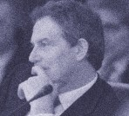Address by Tony Blair Prime Minister
of the United Kingdom

In a world where there are so many sources of instability and anxiety – the Middle East, India/Pakistan to name only two – this new relationship between Russia and NATO is an act of opti- mism and faith in a better, more peaceful future. And it is proof that statesmanship can lie not just in changing reality but also in giving expression to a reality that already exists.

In truth, whatever the history of the Cold War and the traditional suspicions it engendered, the real- ity today is that Russia, North America and Europe confront many of the same challenges and share many of the same goals. The British people do not fear the Russian people. But both British and Russians fear the brutality and malice of international terrorism. Both of us know full well the threat of weapons of mass destruction in the hands of irresponsible or extremist states. All of us have a common interest from the Balkans to Afghanistan in replacing disorder and chaos with order and stability. The Russia-NATO Council gives shape to this reality.

But two points amidst the congratulation. First, this new relationship has to be for real. The table of 20 means just that. Russia is an equal partner. We need to change mindsets as well as institu-
26 tional arrangements. Second, there is work to do, to follow the vision with substance.
On international terrorism, I make a plea: don’t let the passage of time dim our memory of 11 September. The terrorists may be on the run in Afghanistan, but the threat remains. On weapons of mass destruction, this is every bit as potent a threat as international terrorism. Different situations will require different remedies. But doing nothing is not an option. And on defence reform, there is a huge field of potential cooperation. New threats, new ways of working together, require new methods of defence.

So there is much to do. But at least now there is the will to do it. And for that we should be truly thankful.

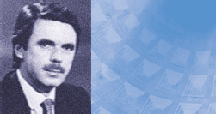Address by
José María Aznar President
of the Government of Spain

First of all, may I welcome you all and say what a pleasure it is to be here, at the first meeting to be held between NATO countries and Russia, as equal partners. I would also like to thank Prime Minister Silvio Berlusconi for his hospitality and for organising this meeting.

Today, Russia is joining the transatlantic community, and by this I am not just referring to a geo- graphical area, but very specifically to the values which constitute our Alliance and our community
– the values which underpin our societies and also constitute the basic foundation of these summits.

Today, these values are much more important than supposed geo-strategic balances for the pur- pose of generating alliances and establishing prosperity. This is something new, something immense, which we tend to regard as normal, but should rather emphasise because it forms part of the most important thing that we can do.

Today, the Atlantic Community is opening its doors to those who are prepared to participate in build- ing peace. So I would like to welcome your friend and mine, Vladimir Putin, and acknowledge all
the work he has done and the efforts he has made to bring Russia here, to the right road. I would 27
also like to register my satisfaction in this respect with everyone who has helped achieve this,
particularly President Bush.

I believe that having overcome the totalitarian attempts, history has left us two lessons to be learned, the first being that values and principles cannot defend themselves alone – action and strength are required in order to defend them. The second is the transcendence of the transatlantic link in this task.

I believe that NATO is a fundamental instrument and we need urgently to transform it, so that it can deal with the new threats and risks that we are now facing.

The experience of the Balkans has brought home to us the extreme risks of radical nationalism and, tragically, the 11 September was a brutal reminder of the extreme risk of terrorism. I am convinced that we cannot and must not sit back and wait to be attacked, but that we must be prepared for any aggression and be ready to act and prevent any damage to our community of values. In my opin- ion, only if we clearly give priority to our efforts against those risks and those threats will we prop- erly fulfil our responsibility as governments in our countries and as leaders of the Atlantic commu- nity. Since I see an opportunity to do just that through this NATO-Russia Council, I hope that we will make effective use of the opportunity offered.

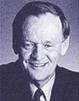Address by Jean Chrétien
Prime Minister of Canada

Today, we begin a new chapter in strengthening our ties with Russia. The new NATO-Russia Council – a council of 20 equal partners – offers us a huge opportunity and an enormous challenge. It is an opportunity to end the remaining divisions of the Cold War and to build a truly reunited Europe. But it also challenges us to find solutions, to compromise and discover new ways of work- ing together. This new Council will be good for NATO and good for Russia.

In the past decade, the process of welcoming a democratic Russia into the institutions of the West has already borne fruit. It will be no different for NATO. In 1995, I invited then President Yeltsin to join the G-7 at the Halifax Summit. We created what is now called the G-8. At the time, there were plenty of doubters about the wisdom of such a step. In a few weeks, the G-8 will be meeting once again in Canada. And no one now doubts that it was the right thing to do. The G-8 has helped coor- dinate policies to increase global prosperity, to assist the poorest of the poor, to protect our envi- ronment, to reduce tensions around the world, and to combat terrorism.

Russia has played a full and essential role in that effort. Now it is time for the countries of NATO to include Russia more directly in their deliberations. After all, we share a common goal: peace and
28 prosperity in the Euro-Atlantic region. I believe the people of Russia are no less interested in that goal than the people in any of our countries. It was to achieve this goal that NATO was founded in 1949. Today, we have the opportunity to bring that goal closer. This is why Canada, as one of the founding members of the Alliance, has been at the forefront in proposing the idea of a new council “at 20”. And pushing hard for its realisation.

Our country will spare no effort to ensure the success of the NATO-Russia Council. But it is incum- bent on each of us to display the political will to make the necessary concessions. This is an essen- tial condition if we are to undertake joint initiatives and actions to create more solid links and pre- vent future conflicts. This is a reality that presses more urgently today than ever.

The tragic events of 11 September last year brought to light the new threats confronting our coun- tries. Canadians felt that they were a target of these attacks. It is up to us to prevent terrorists from laying their hands on nuclear, chemical or biological weapons. Our representatives should work “at 20” and develop initiatives to prevent such a possibility. We can then come to an agreement on these initiatives in Prague. This is necessary for our mutual defence. Without Russia we will not succeed. This is why it has been clear to us that a G-8 and a NATO-Russia Council “at 20” strength- ens our security.

Russia has made enormous strides in recent years in taking its rightful place among the democrat- ic nations of the West. President Putin is to be congratulated, as should we all, in having the fore- sight to see the vast potential that our new Council offers. I look forward at the nearest opportunity to reviewing with you the fruits of our work. Our people will expect no less.

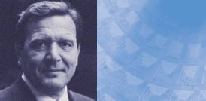Address by Gerhard Schröder
Chancellor of the Federal Republic of Germany

I would like to thank Prime Minister Berlusconi for his invitation and hospitality and for his excellent preparation and organisation of this summit.

We are celebrating a historic event today. With the signing of the Declaration of Rome, relations between NATO and Russia will reach a whole new level.

Russia is being included as an equal partner in the work of the North Atlantic Alliance on a number of important issues. The antagonism between East and West in Europe will thus finally be a thing of the past. We are ushering in a new era of trust and cooperation.

With the signing of the Founding Act almost exactly five years ago, NATO and the Russian Federation drew the necessary conclusions from the dramatic transformation of the strategic envi- ronment after the disappearance of the Iron Curtain and the end of the East-West confrontation. The Founding Act will remain the bedrock of our relations.

In the Founding Act, NATO and Russia committed themselves for the first time to cooperation in
order to contribute to common and comprehensive security in Europe on the basis of shared val- 29
ues, obligations and rules of conduct. Cooperation in the previous forum, the Permanent Joint Council, was the first step. Initially it was a matter of moving from confrontation to systematic coop- eration. Even if not all expectations have been fulfilled, we have become much closer in the last five years.

Today, we are going one step further and opening a new chapter in relations between NATO and Russia. With his forward-looking and resolute policy following the terrorist attacks of 11 September, President Putin created the crucial prerequisite for this to happen. In relations with NATO, he was keen to overcome ingrained mistrust and jointly to tackle international problems, such as terrorism.

In the new NATO-Russia Council which now has to start operating quickly, Russia will work as an equal partner preparing Alliance decisions and bear joint responsibility with the NATO countries for their implementation. The work of the new forum will focus on areas which are of particular impor- tance for guaranteeing security and stability. Let me just mention here the analysis of terrorist threats, strengthening arms control and confidence-building measures on nuclear weapons and protection from weapons of mass destruction. The first results are expected in time for the NATO summit in Prague in November this year. I would be delighted if we, President Putin, could then take stock of developments together.

We have to be aware that the NATO-Russia Council can only be successful if all participants coop- erate constructively on the basis of trust. We have shared interests. In day-to-day cooperation, our governments ought to be guided by these shared interests.

To this end, I wish President Putin both good fortune and success as he continues to pursue his policy of opening up his country. And I hope we can all maintain the spirit of cooperation that inspires us today.

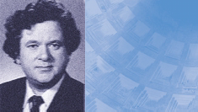Address by David Oddsson
Prime Minister of Iceland

My thanks to Prime Minister Berlusconi for inviting us to meet here in Rome, one of the greatest cities if not the greatest in world history and civilisation.

The Rome Summit has a double purpose. On the one hand, it is a ratification of a historic accord between NATO and Russia. On the other, it is a promise by 20 free states, committed to the rule of law and democracy, to counter any terrorist forces and any actions by them against peace-loving nations or their citizens. The founders of NATO never even permitted themselves the luxury of dreaming about the former, and the risk of global war loomed over them like a nightmare for decades. However, there is no doubt that they would have welcomed the collective show of deter- mination and steadfastness against terrorist networks and the individuals or states that try to assist them in perpetrating their evil deeds.

Winston Churchill, the European politician who was the most enthusiastic advocate of consolidat- ing the transatlantic link with mighty bonds, and tying it together with knots that would never be undone, would not have flinched at giving a piece of his mind to the forces that regard an ambush on peaceful citizens as somehow strengthening their miserable schemes. Of such men, he said:
30 “We will have no truce or parley with you, or the grisly gang who do your wicked will. You do your worst – and we will do our best.”

After the agreement between NATO and Russia today, peace-loving nations, are more capable than ever of doing their best to get the better of those who do their worst.

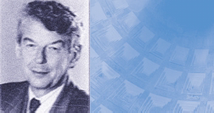Address by Wim Kok
Prime Minister of the Netherlands

Jean Monnet, one of the founding fathers of today’s European Union, said that Europe will not be built as a complete structure, nor will it be built overnight; it will be built in a series of concrete achievements, creating first of all a de facto solidarity. The same goes for our common aim of cre- ating a transatlantic zone of peace, security and stability spreading from Vancouver to Vladivostok. Today’s inaugural session of the NATO-Russia Council is a concrete step forward on the path of ever growing cooperation between NATO and Russia, which we started some ten years ago.

I want to congratulate Secretary General Lord Robertson and his staff and President Putin’s nego- tiators for their successful conclusion of this agreement. This success has been brought about by a fundamental change in our strategic security environment: it is no longer each other that we fear.

Both NATO and Russia increasingly have to cope with the same security challenges, such as ter- rorism, proliferation and regional instability, and we have the same security interests. Former adver- saries have now become partners in creating democracy and the rule of law, peace and stability in Europe. A step rightly qualified as historic.

The Netherlands wholeheartedly welcomes the development. Seeing the flagpoles of the 20 coun- 31
tries of the NATO-Russia Council standing together is symbolic for our determination to give new substance to our cooperation. It also reminds me of the centuries-old relations between Russia and the Netherlands. For the Russian word “flagshtok”, meaning flagpole, is a Dutch word. It dates back to our close ties in the times of Peter the Great.

The most important challenge now is to make the NATO-Russia Council a strong and result-orient- ed framework for practical cooperation. So let’s all commit ourselves to come up with good results soon, even before the Prague Summit.

Success feeds on itself!

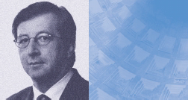Address by
Jean-Claude Juncker
Prime Minister of Luxembourg
©SIP

My father, born in 1924 a few years after the First World War, was obliged – such being the way of the world – to join the ranks against his will during the Second World War. Alongside other men and women of his generation, he contributed to making a reconciled Western Europe a tangible reality for his children.

I was born thirty years later in 1954, just after Tony Blair, who is clearly older than I am. As a young lad I saw the traces of the Second World War in our towns and villages, and, still young, I saw in the faces of those who had returned from the battlefields the war wounds which continued to over- whelm them. I grew up in the atmosphere of post-Second World War Europe, a Cold War atmos- phere. True, the world was much easier to interpret than it is today. There were the good guys and there were the bad guys and, by conviction and through national and individual processes, we knew instinctively where we should position ourselves, take sides, line up. As simple as it was, this world was very dangerous, anguished, offering no prospects for young people.

Today, interpreting the world has become more complicated. There are new challenges, the enor- mous threat of terrorism – a threat not only to the United States but also to humanity – a daily strug-
32 gle, which is likely to continue for several years to come. Interpreting the world may have become more complicated, but the prospects have become happy prospects, because the anguish on our continent is disappearing. Young people are full of hope. Today we know that our children, the gen- eration following us, will not know war in Europe.

A lucky autobiographical coincidence has made us the notaries of this reconciliation between the two parts of Europe – notaries, actors and eternal beneficiaries of the results of this reconciliation between the two halves of peaceful Europe. As one of the youngest here, I should like to pay hom- age to those who made it all possible, those who liberated Europe at the end of the Second World War, those who stood by it unflinchingly during those dangerous and unstable decades. I also pay tribute to the President of the Russian Federation, who has taken it upon himself to take this impor- tant step, a continental step.

This Roman day is a good day for Europe, for transatlantic solidarity and for the young people of tomorrow. Today, those throughout the world who engage in foolish conflicts would do well to look towards Europe, which, together with the Russians and our transatlantic friends, has learnt its les- sons from history.

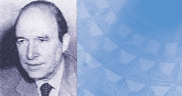Address by Costas Simitis
Prime Minister of Greece

Greece has had intense experiences of the Cold War, of insecurity and fear in a world of violent conflict. It suffered the economic setbacks and poverty that were the result of the friction. Two gen- erations of Greeks were raised believing that in international relations there is only black and white, only two great enemies and the danger of total destruction.

Greece became cut off from the world of the Balkans, where Hellenism had flourished for two cen- turies and Greeks worked from Trieste to Odessa and from the shores of the Adriatic to the shores of the Caucasus. After the end of the Second World War, the economic cooperation and commu- nication between peoples that had brought prosperity became impossible.

In 1989, the socialist system collapsed. Once again, bridges of cooperation began to be built. From the very outset of the realignments in Eastern Europe my country was in favour of close and fun- damental cooperation with Russia. We believed then and believe now that without cooperation with Russia there can be no lasting peace and stability in Europe. Yet, ten years went by before we could truly say that not only has an era come to an end, but that relations have been normalised and we are definitely entering a new era.

33
Today marks the formal ending of the Cold War. Today hope is reborn – the hope and conviction that we can go forward together. That is why I salute the new relations that are being forged between NATO and Russia. I welcome President Putin in our midst.

We find ourselves facing new challenges. It is a realisation that all of us at this table experienced following the tragic events of 11 September. Together, we must and can respond to the challenge of terrorism. At the same time onerous legacies still exist from the century that just ended.

This day must become a symbol and an example for such other regional trouble spots that exist. It must become an example of how to overcome problems that beset us, on how history continues on new foundations. But we must all make every effort to ensure that this great fragile zone that begins from the Balkans and reaches to the Middle East becomes a region of peace and stability.

What is needed is the political will, the dedication to the principles and the values of a modern world of mutual understanding that condemns violence. What is needed is a vision of peace and friend- ship for the world to pass on to the generations that will come after us. We, the Greek government, will work with consistency and persistence towards this goal.

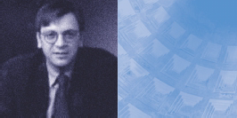Address by
Guy Verhofstadt
Prime Minister of Belgium

This meeting marks a new stage, even a revolution, in the relationship between the North Atlantic Alliance and the Russian Federation. Today, in creating this Council at 20, we give new meaning to the cooperation between the Alliance and Russia. As from today, Russia will be directly associated with formulating our answers to new threats against stability and peace, in Europe and in the rest of the world.

This is crucial for three reasons. First, for our relations, which today we raise to a higher level. This is indeed a milestone on the way to uniting the European continent, made possible only because Russian society has profoundly transformed itself during the past decade. The values of democra- cy, rule of law and free market now constitute the basis of this society – values that have given rise to the common security interests that we share today. As from today, NATO and Russia will empha- sise what unites them, not what separates them.

Second, through the Rome Declaration, Russia is recognised as a privileged partner. In this climate of confidence, the accession of new members to NATO should no longer raise strong emotions. Enlarging NATO, like adopting the Rome Declaration, is indeed about building the unity of Europe.
34 Above all, it is about putting an end to the injustice caused by the Cold War, which divided peoples without any consideration for their most profound aspirations. This is why the Belgian government is in favour of a broad enlargement.

Finally, this new relationship will reinforce the political and military means at our disposal to defend and promote democracy, peace and stability on the continent and in the world. This Council and this cooperation with Russia opens new perspectives in crisis management. In the Balkans, for instance, NATO and the European Union already work together, thus avoiding duplication of effort. We must now further open this cooperation to Russia.

Furthermore, all our governments currently face budgetary restrictions. In this context, specialisa- tion, pooling of resources, and even division of tasks and missions are ever more necessary. Of course, this evolution is the result of necessity. But above all, it is possible because of the trust we share.

Similarly, these new forms of cooperation will allow us to address together the challenges of war on terrorism. The events of 11 September have shown that all of us – Europeans and Russians as well as Americans – face threats our societies were not prepared for. Today, to wage this war, we need a whole range of instruments: political, judicial, financial, economic and military. Still, we must be wary of one possible risk. I have no doubt that we must build the largest coalition possible against terrorism. However, in doing so, we must restrict ourselves in the regimes we associate with and the means we employ. Indeed, the best way to combat terrorism is and will remain the defence and the promotion of the values of democracy, free speech, free press and free association. These are precisely the values that terrorism wants to destroy. These are the values that allowed us, in the past, to defeat fascism and communism. And I am sure these shared values will allow us to over- come terrorism.

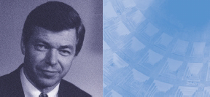Address by
Kjell Magne Bondevik Prime Minister of Norway

Thank you Secretary General for guiding the Alliance with your steady hand, at a time when we open a new page in our relations with Russia. Thank you, Prime Minister Berlusconi, for hosting this historic summit.

For years, we have been saying that genuine security in Europe can only become a reality if NATO and Russia join forces and work together. In signing the Rome Declaration, we make good on that pledge. I agree with UK Prime Minister Tony Blair that we have to be concrete in our follow-up for the Council to be a success. I strongly welcome the establishment of the NATO-Russia Council. It gives us a more effective instrument for building a stable, peaceful and undivided Europe. And it allows for the integration of Russia as an equal partner in the Euro-Atlantic family.

I strongly welcome the decisions taken by Presidents Bush and Putin on major nuclear arms reduc- tions. At a crucial juncture, facing the threat of terrorism on an unprecedented scale, you have demonstrated true leadership. I strongly welcome your dedication, President Putin, to engage Russia in an ever-closer cooperative relationship with your European and Atlantic partners.

Ours is a world of innovation and fast change. Looking back, though, from a historical perspective, 35
it is nothing less than a miracle, that in a course of a decade we have bridged the gap and come this far.

Norway and Russia are neighbours in the North. We share an important and broad bilateral agen- da: energy, marine resources, environment, security. I am confident that our work in the new NATO- Russia Council, based on openness, trust and confidence, will also have a positive impact on this agenda. Nuclear safety is one issue. New security threats have made this more important than ever. We will continue working with Russia in efforts for safe disposal and storage of nuclear-relat- ed material. I also look forward to the state visit by President Putin to Norway in the autumn.

With the NATO-Russia Council we have been given a unique, new opportunity. It is now for us to seize it, and make it a continuing success story. NATO-Russia cooperation will yield benefits from day one. But more importantly, we will reap great benefits in the longer term, as shared security – and the “Spirit of Rome” – becomes not only our vision, but our reality.

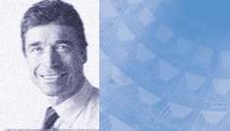Address by
Anders Fogh Rasmussen Prime Minister of Denmark

At this first meeting of the NATO-Russia Council, I take real pleasure in representing Denmark. My country attaches the strongest importance to the closer relations we inaugurate today between our Alliance and the Russian Federation – a historic event in building the new security system in Europe. It is another sign of how much and how quickly everything has changed: old adversaries are now close partners, who share a common interest in fighting the new threat of terrorism.

First, I should like to congratulate the Presidents of the United States and the Russian Federation on the impressive results of their meetings in Moscow and St. Petersburg last week, in particular the Treaty on deep cuts in offensive strategic arms.

We have great expectations for the work of the NATO-Russia Council. Twenty, and soon quite a few more, members of this Council – big and small – will be joining their efforts in this new body. We need to demonstrate real progress and do it reasonably quickly to achieve momentum. I am con- fident that, after some time, the new Council will move NATO-Russia relations to a higher level of development, performing in a cooperative and constructive atmosphere.
36 Here, at the beginning of this promising stage of our relations, I would in particular like to highlight the fight against terrorism as a crucial area for cooperation. Counter-terrorism is our common con- cern and to a large extent the element that led to this new beginning in NATO-Russia relations. The military component is not the only or even the most important part of the struggle. Our new Council will be involved in the broader political consultations that precede important decisions in many areas on how to deal with the threat.

We also share a strong interest in preventing the spread of weapons of mass destruction and their means of delivery to irresponsible owners and operators. Much necessary work remains to be done in this area, and Russia is uniquely positioned to contribute to making our world more secure.

The more rapidly headway is made on issues such as these, the more progress will follow on the other subjects listed in our declaration. Success will generate success.

Denmark is a nation with a record of many centuries of peaceful relations with our great neighbour on the Baltic Sea. This is how we see the work we are beginning today in the NATO-Russia Council.

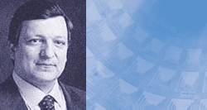Address by
José Manuel Durão Barroso Prime Minister of Portugal

Thank you Secretary General and thank you Prime Minister Berlusconi for hosting this meeting. Thank you also for your lesson in classical history. History is something we should keep in mind because we believe that today we are writing the history of the future.

We are happy to have Russia as our neighbour at this table. Portugal, the most westerly of the con- tinental European countries gains in this way a new geographical proximity with Russia. And, let me tell you, President Putin, that between Portugal and Spain is a very comfortable place to be.

We are now following what President Putin once called “the logic of common interests”. And we hope that we are not only speaking of common interests but also of common values.

Acting together is the best way to respond to the new – and some old – challenges NATO and Russia face. Terrorism has no boundaries as the tragic events of 11 September have shown. The same could be said of organised crime and of trafficking in drugs and human beings. Curbing regional conflicts and the proliferation of weapons of mass destruction are also key areas where Russia and NATO should act jointly.

37
The past is not a bad witness. Coordinated action against common evils will certainly benefit from the energy, determination and endurance that have been constant features of Russian history. We have no time to lose. We must inject substance to our new structures of cooperation. Above all, we must spread the habit of working together at all levels, applying fully the principles of trust and transparency.

Uniting Europe in freedom, democracy and security is our common endeavour. Making the NATO- Russia Council work properly is in our common interest. This is the right way to promote our values.

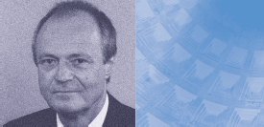Address by Péter Medgyessy Prime Minister
of the Republic of Hungary

I join you here today to deliver a clear message at a historic moment, on this unique occasion when the Alliance and Russia together form the solid foundation of an international effort for peace, secu- rity and prosperity.

It was yesterday, just before departing for this summit that I took my inaugural oath as Prime Minister of Hungary. The message my nation entrusted me to bring here is “commitment”:
- my government’s commitment to keep our Alliance strong and effective;
- the commitment to honour our obligations and meet our responsibilities;
- the commitment to contribute to preserving NATO as the cornerstone of the transatlantic rela- tionship, with the right means and capabilities to meet the challenges of the 21st century;
- the commitment to find new answers and methods, as symbolised by the creation of this NATO- Russia Council, to meet these new challenges in the most efficient way possible.

We meet as custodians of security, stability, democracy and prosperity. Only together and in coop- eration can we attain and promote these values. The need for cooperation has been further rein-
38 forced by the threat of international terrorism. There is no doubt today: we are resolved to cooper-
ate. Now that we have understood this, a new period of confidence and cooperation between NATO and Russia can begin.

It is now our joint duty to lay the broadest possible foundations for all the nations ready to engage in combating the scourge of terrorism. I see the Allies and Russia at the centre of this combat. The courageous steps taken following 11 September have convinced me of this.

Five years have passed since the NATO-Russia Founding Act was signed. This document still serves as the firm basis of dialogue between the Alliance and the Russian Federation. Today, we wish to express our satisfaction at the prospect of a qualitatively new, even tighter cooperative framework. The agreement we are going to adopt during this summit represents the success of our cooperation.

Hungary is ready to contribute to the Council’s work. We are convinced that the NATO-Russia agreement will also help us to develop a higher-level, more beneficial partnership between the nations of Central and Eastern Europe and the Russian Federation.

Democratic Russia is an important partner for Hungary. My government and I personally are ready to seek new ways of enhancing this cooperation. Together with the other NATO member nations, Hungary will work to discover all the opportunities presented by the new NATO-Russia Council.

It is in this spirit that I wish all of us great success in transforming our relations based on common interests to a genuine cooperation, based on common values and a new and stronger partnership, which has winners only.

Unless otherwise indicated, all photos are © NATO

© NATO - 2002

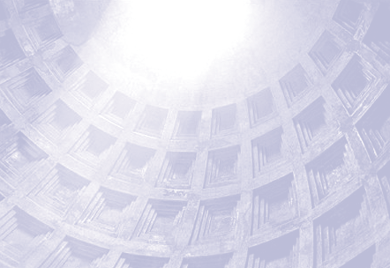

NATO Office of Information and Press
1110 Brussels - Belgium Web site: www.nato.int
E-mail: natodoc@hq.nato.int
ROMSUMEN

